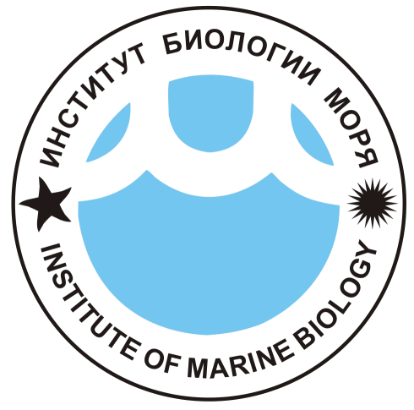
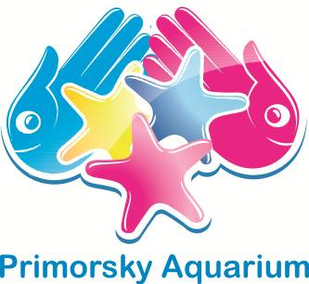
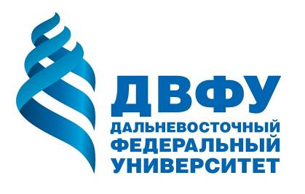

МЕЖДУНАРОДНАЯ КОНФЕРЕНЦИЯ
Уникальные морские экосистемы: современные технологии изучения и сохранения для будущих поколений, Владивосток, 4–7 августа 2016 г.

INTERNATIONAL CONFERENCE
Unique marine ecosystems: modern technologies of explorations and conservation for future generations, Vladivostok, Russia, August 4–7, 2016

REGISTRATION FORM
Please, fill in and return by e-mail to:
Ms. Marina Gorelaia - mgorelaia@mail.ru

Registration deadline: April 20, 2016

Submission of Abstracts deadline: April 20, 2016
Abstracts must be submitted to:
Dr. Olga Shevchenko - islandrussky2016@yandex.ru

Personal Information
Title |  Prof.  Dr.  Mr.  Mrs.  Ms.  Other:
Given Name(s)
Family Name
Affiliation (Institution)
Address
City, State, Zip Code
Country
Phone No. |  | Fax No.
E-mail(s)
Accompanying Person |  Mr.  Mrs.  Ms. Family name: Given Name:
Accompanying Person |  Mr.  Mrs.  Ms. Family name: Given Name:

Presentation
Presentation Title
Type of Presentation | Oral | Poster

Visa support
Please, inform us whether you need visa support or no (depending on your nationality and/or passport type).
The citizens of 40 countries and territories are eligible to visit Russia with a valid passport and without obtaining a visa in advance. In other cases, you need to obtain an ordinary humanitarian visa for designated period. For scientific visits/workshops visa application, you need an official invitation letter of two kinds: one may be issued by the inviting institution (China, many European countries), and another one – only by a local branch of the Russian Federal Immigration Service (FIS) (USA, Canada, Japan, etc.). The FIS invitation process may take up to two months prior to issuance of invitation! If you need to apply for this visa, please, contact Ms. Marina Gorelaia (mgorelaia@mail.ru) at the Secretariat of the conference, and she will provide you with necessary details. The official invitation letter will be sent to you as soon as possible depending on procedure. Please, consult websites of Russian embassies/consulates in your countries for further details. Preparation of Russian visas may take a long time, so, please start this process as early as possible.
Additional important information: Vladivostok got the status of "porto franco" (free port) in 2015 (Federal Law N 212-FZ, 13 July 2015, entered into force 12 October 2015). According to the law, visa-free regime in the territory of a free port would be implemented, so, foreign citizens would be allowed to stay for 8 days; the list of countries will be approved by decree of the Government. However, the Vladivostok visa-free regime was postponed indefinitely in January 2016.

Participation in excursions
Tours | Participation
City tour | Yes | No
Primorsky Aquarium tour | Yes | No
Institute of Marine Biology tour | Yes | No

General information: Dr. Konstantin Lutaenko, Coordinator – lutaenko@mail.ru

