

Job Announcement: Open Positions for Research Fellows and Post-docs at the APEC Climate Center

The APEC Climate Center (APCC), located in Busan, Korea, is looking for motivated scientists for the areas described below:

- Climate variability and predictability

  - Monitoring and Analysis of climate variability and extreme events (e.g. drought and flood)

  - Understanding and enhancing climate predictability (ensemble prediction, probabilistic forecasting, multi model ensemble forecasting, and statistical post-processing and calibration) for the subseasonal to decadal time scales

  - Numerical modeling of coupled climate systems (atmosphere, ocean, land surface, sea-ice, and etc) and its initialization

- Assessment of climate change impacts and climate applications

  - In-depth analysis of climate change scenarios in the Asia-Pacific region

  - Application of climate information to climate-sensitive sectors (Agriculture, Water resources, Energy, Health, Economics, etc.) to minimize climate risk, to help APEC member economies’ plan for adverse and beneficial climate events, and to achieve development goals

  - Developing climate information services for various users

Qualifications : Applicants should have a Ph. D in climate sciences, climate change, economics or a relevant fields.

Benefits : Partial coverage of health and other insurance (according to Korean law), support for relocation to and housing in Busan, severance pay, performance-based incentives, and more.

To apply :
Submit the application form (available for download at http://www.apcc21.org/eng/notice/opp/japcc0503_lst.jsp) with a cover letter, a Curriculum Vitae and three letters of recommendation to Mr. Seungwon Chung (swchung@apcc21.org) by 2 December 2012. For more information, please contact Mr. Seungwon Chung (swchung@apcc21.org).

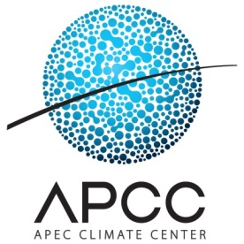
The APEC Climate Center (www.apcc21.org) was established with the endorsement of APEC Senior Officials in 2005. Its mandate is to provide climate information services to the 21 APEC member economies in order to promote human security and protect life and property from the hazards associated with extreme climate events. Since its establishment, APCC has steadily gained momentum in becoming a leading provider of various climate forecast products and capacity building programs in the region. Currently, APCC is expanding its areas of research and services to cater to wider socio-economic needs and interests.

