Strengthening Adaptive Capacities of Small Holding South Asian Agrarian Community through Climate Information Network-Based Decision Support Tool
Amitava Aich^{1*}, Dipayan Dey¹, Malancha Dey¹, Udita Ghosh Sarkar¹, Arindam Roy²
¹South Asian Forum for Environment (SAFE), 176 A Vivekananda Park, Ajoynagar, Kolkata, WB, India, Postal Code 700099

²EPFL (École polytechniquefédérale de Lausanne), RteCantonale, 1015 Lausanne, Switzerland

*Corresponding author. Email: amitavaaich@gmail.com; Tel: +91 9831409997

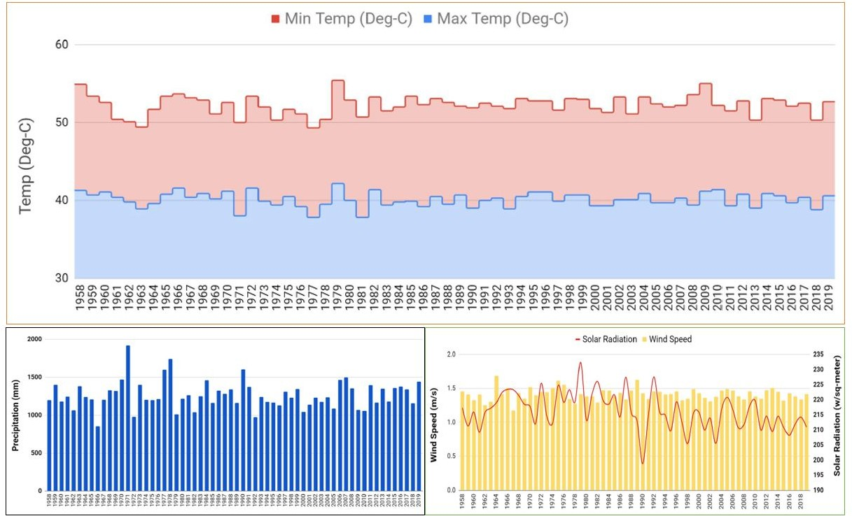
Supplementary Material-Appendix 3
Fig. S1. Annual historical temperature, precipitation, wind speed and solar radiation pattern for Purulia

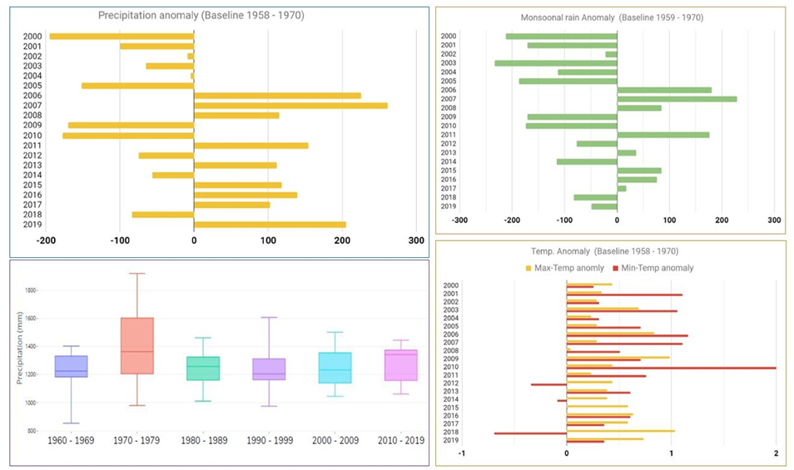

Fig. S2. Precipitation and temperature anomaly in the last two decades in Purulia.

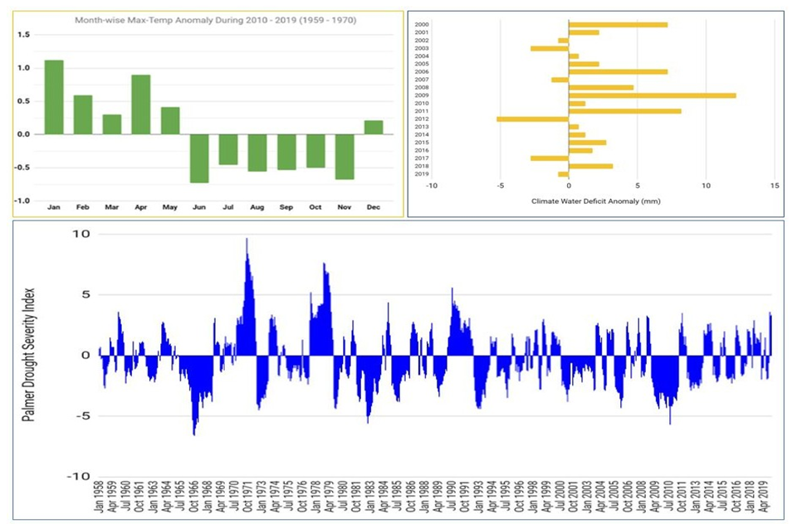

Fig. S3. Pattern in Agro-climatic indices over Purulia
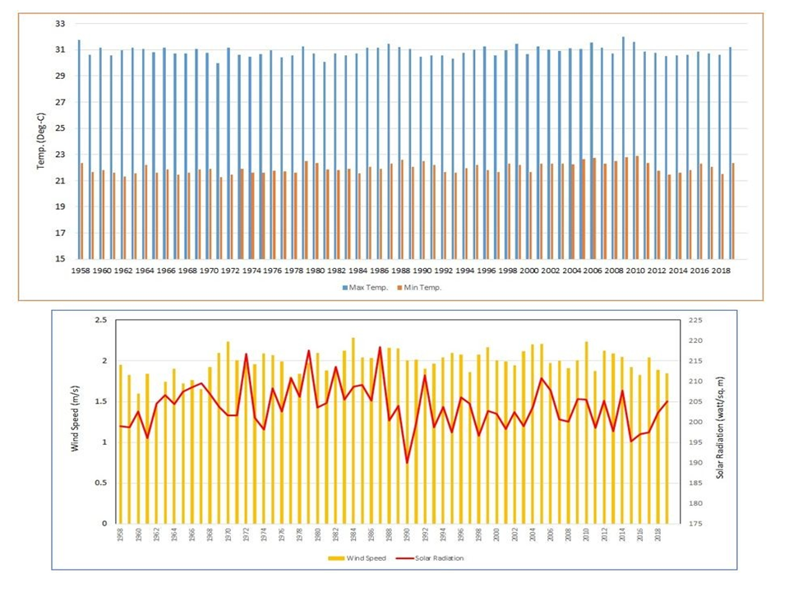

Fig. S4. Annual pattern in temperature, wind speed and solar radiation over Shyamnagar

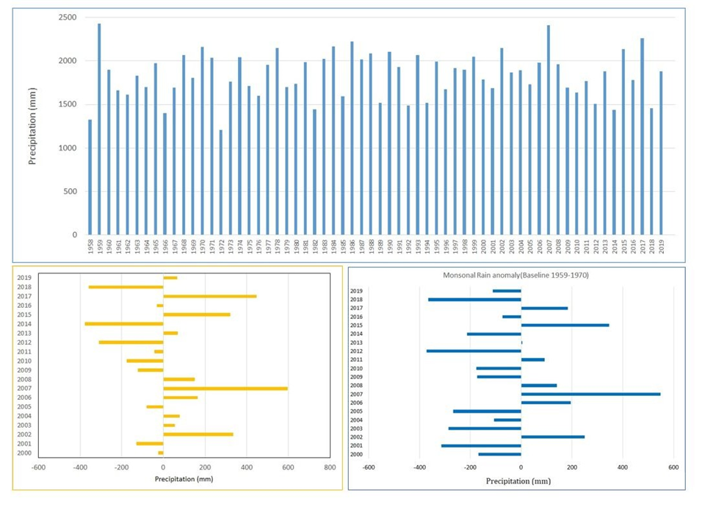

Fig. S5. Precipitation and its anomaly for the last two decades over Shyamnagar

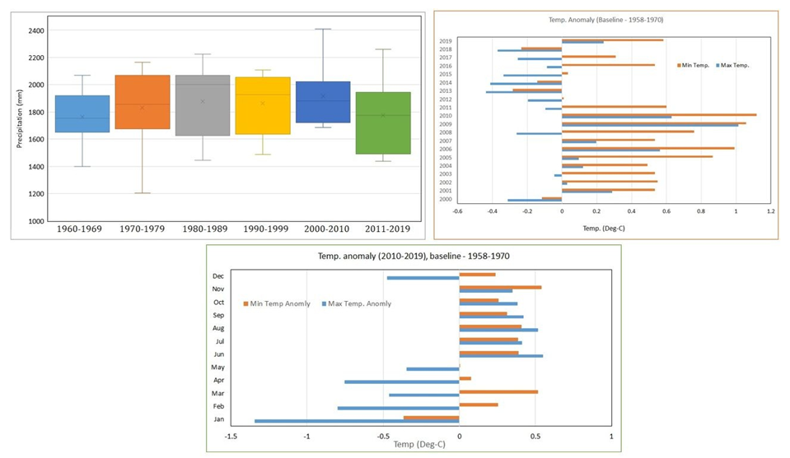

Fig. S6. Decadal precipitation pattern and temperature anomaly over Shaymnagar
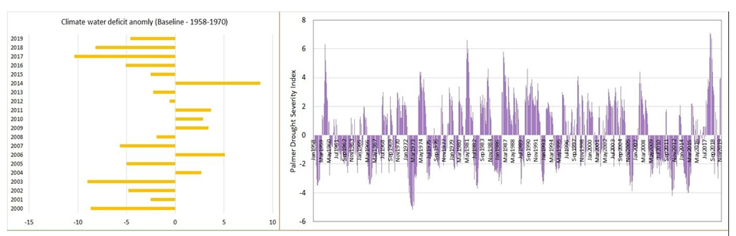

Fig. S7. Climate water deficit anomaly & Palmer drought sensitivity index over Shaymnagar

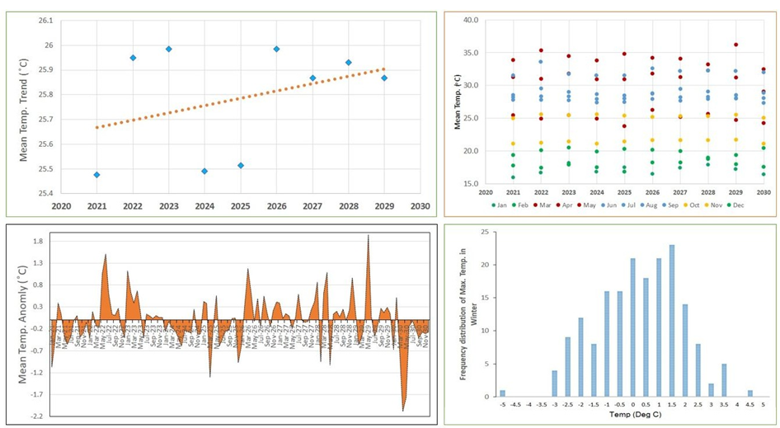

Fig. S8. Future temperature projection over Purulia

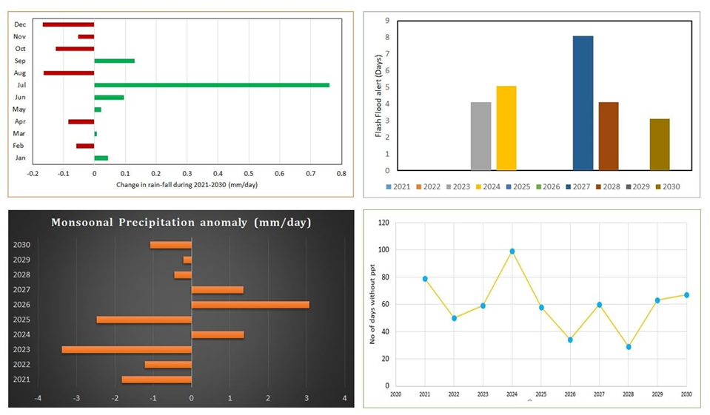

Fig. 9. Precipitation projection over Purulia

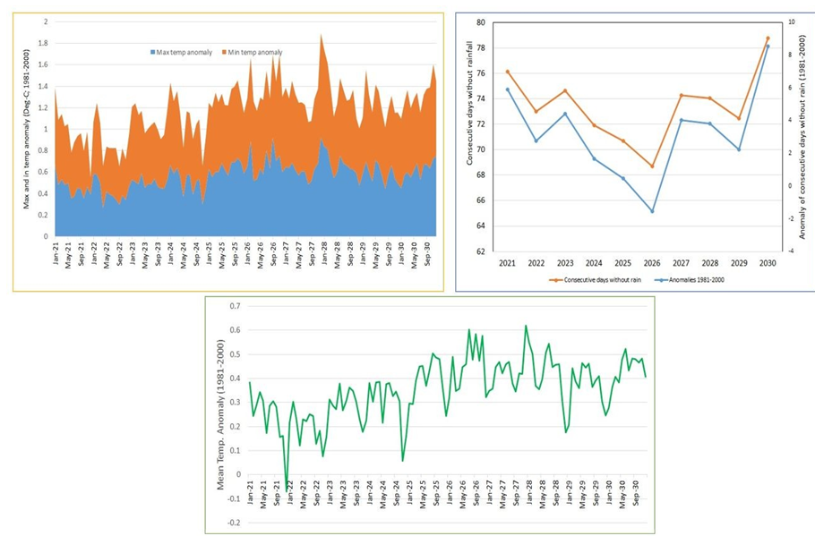

Fig. 10. Temperature and dry spell prediction over Shyamnagar

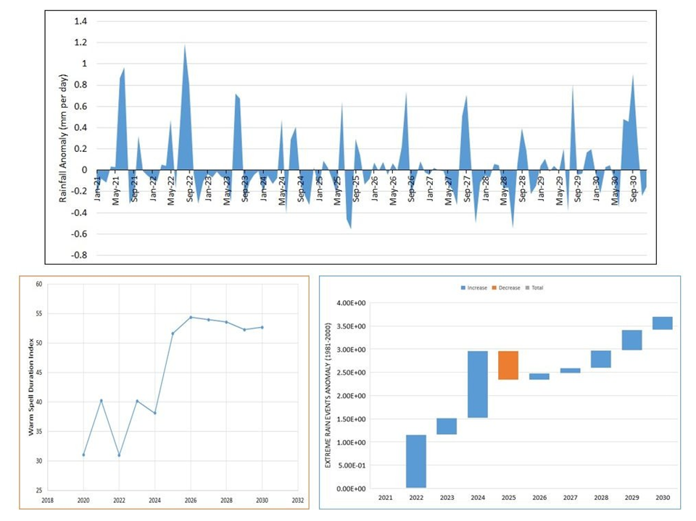

Fig. 11. Predicted precipitation extremes over Shyamnagar
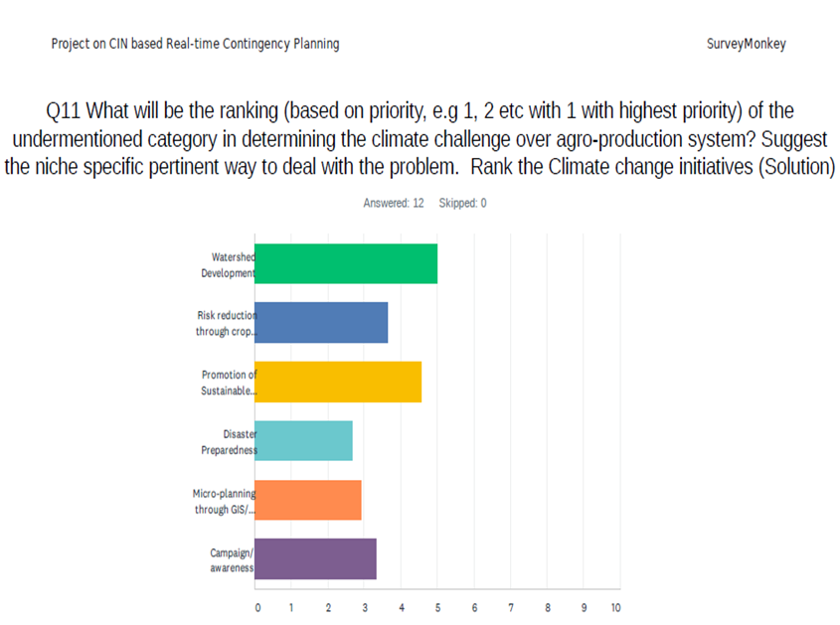
Fig. S12. Opinion on the most visible effect of climate change on agriculture
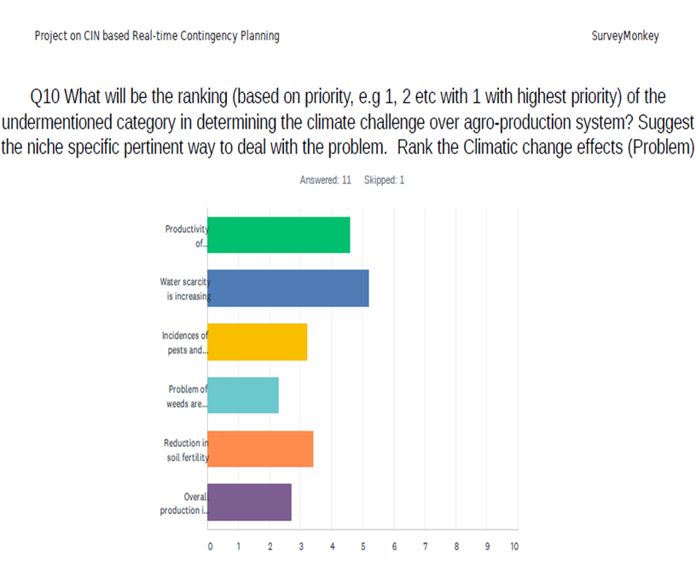

Fig. S13. Opinion on niche-specific and pertinent ways to deal with the effect of climate change on agriculture

